**Accent (n.) (often used as a noun modifier)**

emphasis laid on a part of an artistic design or composition

**b** : an emphasized detail or area; *especially* : a small detail in sharp contrast with its surroundings

**c** : a substance or object used for emphasis a plant used as a decorative *accent*

**Collocations: *accent + noun***

The following are common collocations with accent *+ noun*

accent color, accent wall, accent lighting/lights, accent piece, accent chair

**A House with Color**

**Step 1:** In your group, decide on a room in a typical house: the living room, the kitchen, the bedroom, or the bathroom.

**Step 2:** Draw a simple floorplan. It should include all furniture and appliances.

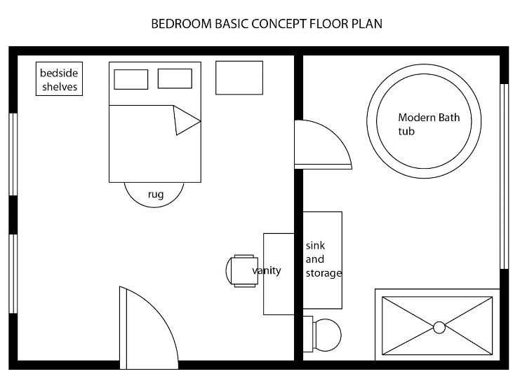

**Step 3:** Use the manila folder to create pieces of furniture for your space.

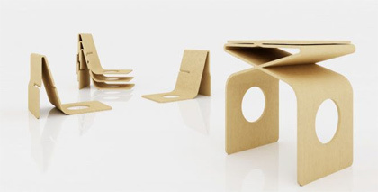

**Step 4:** Use markers and/or construction paper to add colorful accents to the space.

**Step 5:** Share your interior concept with the class and describe what accents are in the space and why you made the decision to add them where you did. Use at least one of the accents in your presentation.